
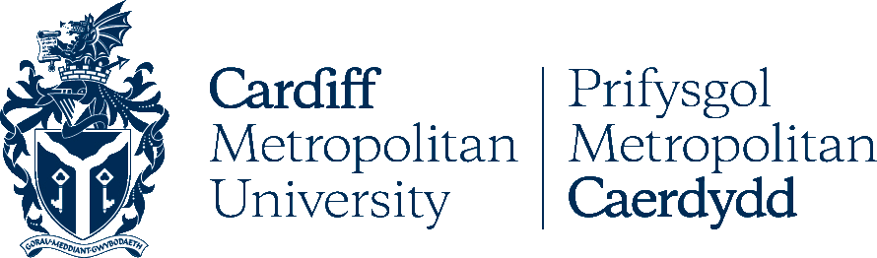
This is to certify that:

And Cardiff Metropolitan University collaborate in relation to the facilitation of advanced entry to a relevant university degree course based on Accredited Prior Learning.

* Students must meet all entry requirements as stated in MOA.
Cardiff Metropolitan University Ly Tu Trong Technical College HCM City
Signature Signature

Date: 25th February 2016

Ly Tu Trong Technical College Ho Chi Minh City

